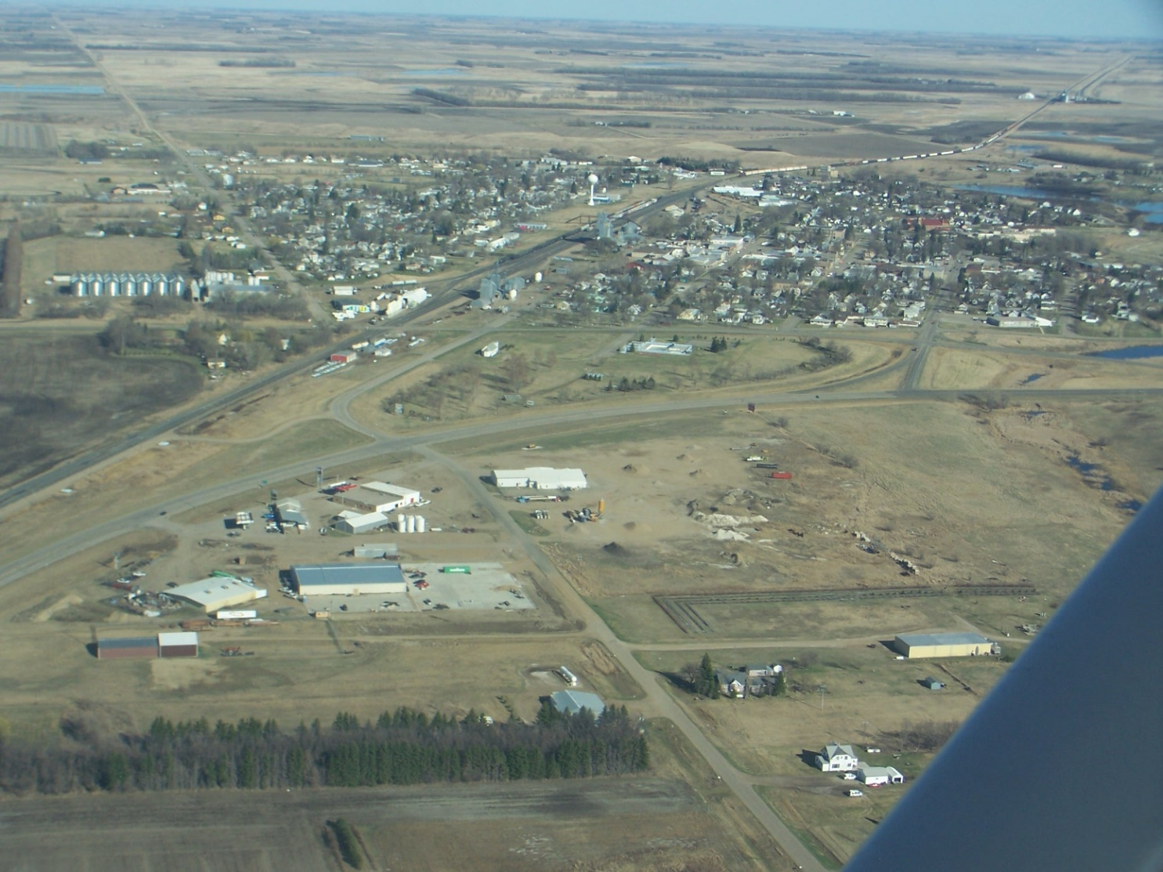
Harvey Economic Development Area – Strategic
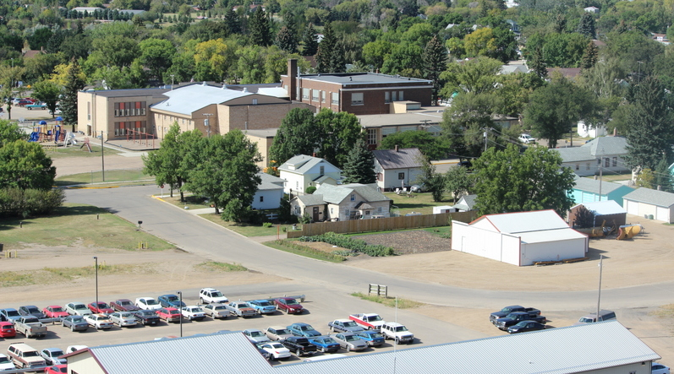
Plan
December 2018

TABLE OF CONTENTS
Background……………………………………………………………………………………………………………………………..3
Harvey’s Strengths…………………………………………………………………………………………………………………..4
Harvey’s Weaknesses………………………………………………………………………………………………………………7
Harvey’s Economic Development Opportunities………………………………………………………………………8
Harvey’s External Threats………………………………………………………………………………………………………..10
Transitioning Toward a Vision for the Future…………………………………………………………………………..12
Harvey’s Core Values……………………………………………………………………………………………………12
Five Objectives Describing Harvey………………………………………………………………………………..13
Expanding Local Business Development Capability……………………………………………………….14
Explore a Local Food Hub Accompanied by Other Retail & Wholesale Opportunity………16
Consider Creating a Sheyenne River Park……………………………………………………………………..17
Expand Downtown Entity Marketing……………………………………………………………………………18
Celebrate Our Heritage………………………………………………………………………………………………..19
Initiate Planning for a One-campus Educational Facility……………………………………………….19
Continue Design of a Competitive Healthcare Environment………………………………………….21
Incentivize Development of Additional People-concentric Housing………………………………22
A View of the Harvey Economic Development Region by Our Millennials, Gen-X
& Gen-Y’ers………………………………………………………………………………………………………………….22
Appendices……………………………………………………………………………………………………………………………..25
List of Acronyms…………………………………………………………………………………………………………..25
Web Site Addressees……………………………………………………………………………………………………26
Economic Development Area Demographics………………………………………………………………..26

Vision for the Future
Harvey Economic Development Area
August-2018
Background
The city of Harvey completed its last strategic plan in 2002. It was anchored upon findings generated by community surveys and work groups formed to focus upon economic development, education, clinical care, fire protection, core utility infrastructure, law enforcement, and other city-owned infrastructure and parks and recreation facilities. At that time, key findings suggested need to (1) encourage and promote substantial and sustainable economic development, (2) evaluate and develop new approaches to law enforcement within the police department, and (3) create a local disaster readiness plan. Future economic development was to focus upon (a) enhancing Harvey’s business environment, (b) pursuing new business entities, primary sector jobs, and retail shopping opportunities, and (c) expansion of existing business entities. Harvey’s police department was expected to absorb (a) additional officer training in tactics and community engagement, and (b) new tactical and other equipment, while the community would constitute and field an advisory Police Committee and develop neighborhood watch capacity. Given the September 11, 2001 attack upon the U.S. and other Harvey City-wide developments, the third key finding involved establishment of a disaster readiness committee, conduct of a multi-hazard mitigation assessment, and creating public awareness of procedures to be deployed in response to future unsettling incidents.

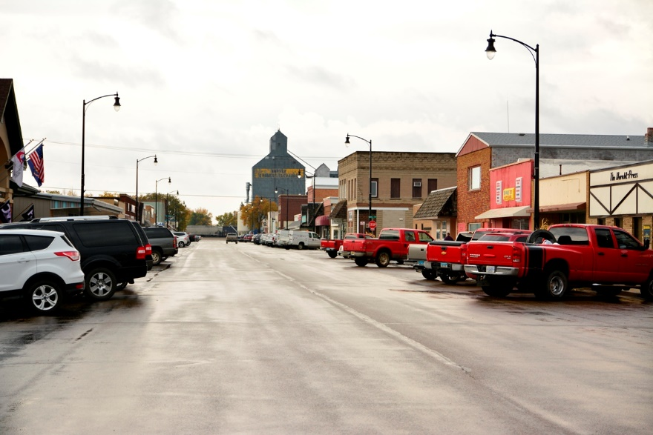
Since 2002 the city has witnessed emergence of new business activity on its main street – Lincoln Avenue, the Industrial Park, the Highway #52 by-pass on the west edge of the city, and along Business Highway’s # 52 & 3 on its eastern and southern edges. It has also experienced closure of some entities and re-purposing of others, including some within its Renaissance Zone, downtown along Lincoln Avenue and along Business Highway # 52. However, substantial new investments have been made to improve, rebuild, or augment the city’s water and sewer underground infrastructure as well as new storage and pumping facilities. Substantial investments have also been made in the city’s parks and other recreation areas, and new facilities for Harvey Ambulance Service. The city of Harvey has also added costly improvements to the fire department, the airport, and the Armory. The Police Department has been strengthened and disaster preparedness and response has improved through benchtop exercises and neighborhood awareness activity. And. St. Aloisius Hospital, and other medical and public health entities have renovated or added space.
Downtown Harvey – Lincoln Avenue in 2018

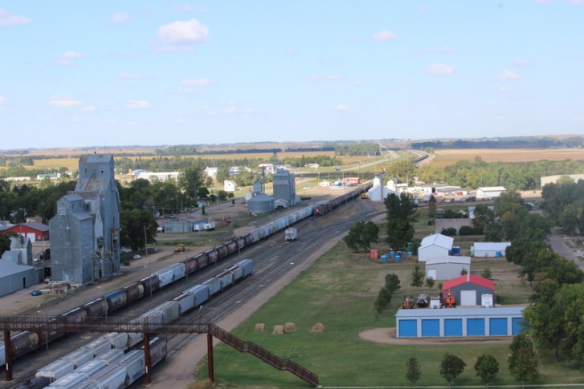
In response to burgeoning agricultural productivity, the explosive development of the Bakken Oil Play, and corporate need to pursue high speed rail capacity the Canadian Pacific Railroad (CP) also introduced major trackage upgrades and capital asset investments within their rural and urban service areas, including Harvey. However, in December 2017 CP Railroad announced plans to relocate most of its Harvey workforce to communities on the northern and eastern edges of North Dakota given its investment in high-speed rail. It would retain its remaining trackage repair staff in Harvey. This development poses a challenge for Harvey as the positions leaving Harvey are typically highly compensated and involve numerous households located in Harvey and adjacent communities. Shortly after this announcement, a Harvey Operation Community Partnership entity emerged to address this and other potential short and long-term implications impacting Harvey’s economic future. Because it takes a whole community to respond to calls for action, the Partnership was composed of Harvey’s business and other cross-sectional organization leaders from agricultural, lifestyle, residential, religious, and recreational communities, who typically met on a bi-weekly basis to explore Harvey’s present and near future. While initially addressing how CP’s decision might be reversed, the Partnership quickly moved to the next recovery stage, launching in January 2018 an internal SWOT analyses that could serve as the basis from which to forge Harvey’s future strategic direction. This analysis is typically undertaken by an organization or entity to identify its internal strengths and weaknesses as well as its external opportunities and threats.
CP Railroad Rail Line Through Harvey

Harvey’s Identified Strengths

Harvey is recognized as a progressive community that is centrally located near the headwaters of the Sheyenne River on busy U.S. Highway # 52 and State Highway # 3. Located at the western entry into the North Country Trail (www.NorthCountryTrail.org) and within the Central Waterfowl Flyway, Harvey is contiguous to numerous fishing and hunting areas, outdoor parks and other recreation areas, hiking trails, and river canoeing. The Lone Tree Wildlife Management Area is nearby, and Harvey possesses its own lake frontage along its south side, as well as a golf course embracing the Sheyenne River on its north side, a rodeo ground, shooting range, racquetball courts, ball diamonds and courts, and indoor recreation areas for use during inclement weather. Local organizations provide leadership and offer gymnastics, baseball, and t-ball, bowling, pee-wee wrestling, youth basketball, firearm safety, youth bow and arrow instruction and other organized recreational and sport activities.

Progressive agricultural farms, ranches and other rural enterprises surround the city, including three implement dealerships (one also houses grain storage structure erection and service), a farm/ranch supply store, an insurance agency, a light manufacturing facility producing short-line equipment, retail fuel and fertilizer supply and delivery entities, a building supply dealership, a modern unit-train capacity grain handling facility that also
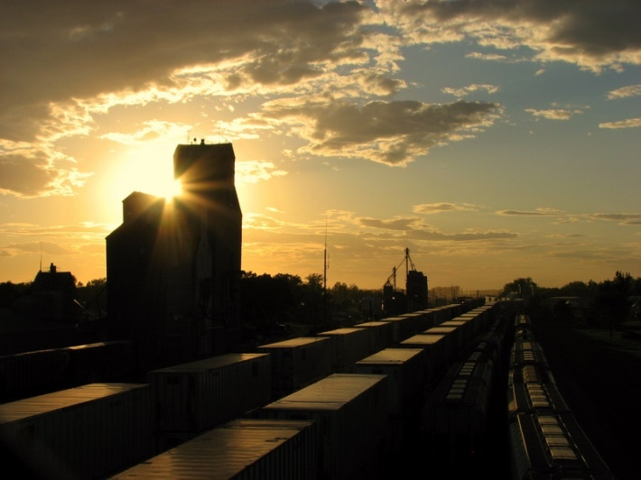
provides grain brokerage and basic agronomy services, a light truck and other dealership, a combine harvester rebuilding entity, an agricultural equipment rental facility, an advanced engine and drivetrain repair and rebuilding facility, rural electrical line transmission construction and repair, LP and other fuel/lubricating product facilities, and an airport catering to commercial, medical, agricultural and ranch production need as well as other aircraft storage and movement. Within Harvey itself are found an emerging flour milling facility, another implement dealership, another farm supply store, a veterinary medical facility, two heavy truck repair firms, tire and radiator repair capability, and firms offering agricultural, and turf and garden implements and repair. Each of the three banks located on Lincoln Avenue, Harvey’s downtown, offer a full range of financial services to local and regional entrepreneurs, farmers and ranchers, and individual households. Other firms offer information technology, accounting and management, insurance and agricultural security services. Still other firms provide rural agricultural building construction, repair, heating and cooling, electrical, plumbing and HVAC installation and repair.
Dusk Within Harvey City

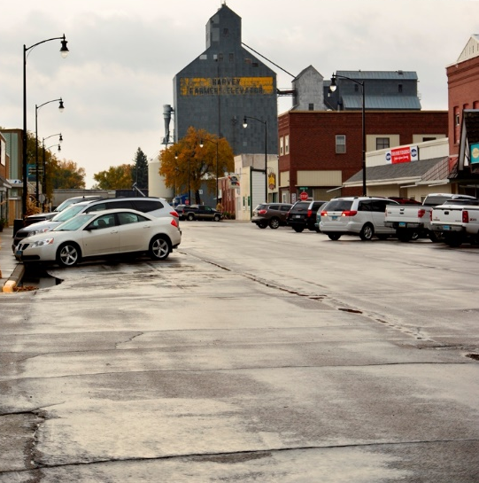
For the needs of its population and that of surrounding areas and smaller communities, downtown Harvey offers an array of restaurants, a movie theatre, its public library, a fuel stop, variety and hardware stores, grocery stores, banking/financial, legal and other services, hair and nail boutiques, artist coves, clothing stores, laundry facilities, the Herald Press newspaper office, a Senior Center, furniture and appliance retailers, an auto body repair facility, beverage outlets, a U.S. Post Office, and some partially developed “sticky spaces’ for visitors and pedestrians within its downtown area. Four worship communities are also located in or near the downtown area. Other “close-in” commercial entities include an excavation/heavy construction firm, HAV-IT’s recycling processing facility, a feed mill and offices accepting and retailing grain and fertilizer, automobile and truck repair facilities, real estate firms, health care facilities, an emerging child care facility, apartment complexes and single-family housing. On its downtown periphery are located other essential retail outlets such as grocery stores, hair and nail boutiques, rail off-load docking, and heavy truck repair. This surrounding area also houses the city’s swimming pool and other park/picnic facilities and an RV park. The Highway 52-bypass is where agricultural service and supply entities, a building center, veterinary clinic, the administrative core offices and other HAV-IT industrial activity, motels, LP and other fuel outlets, excavation firm offices, a ready-mix concrete facility, retail storage, automobile/truck parts outlet, and insurance facilities are located.
Lincoln Avenue Downtown – Weekday Afternoon

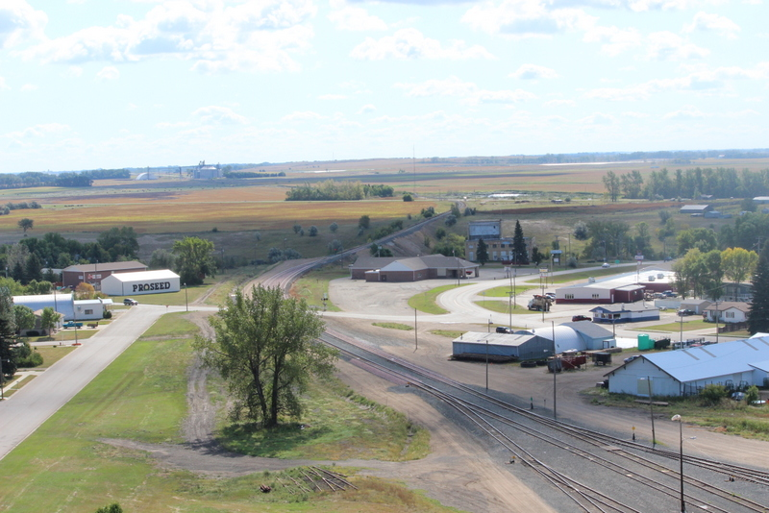
Harvey’s Renaissance Zone incorporating the north end of Business Highway # 52 offers economic development potential and currently contains auto body repair, clothing, farm supply, retail storage, restaurant and other food, and motel facilities. It also encompasses the non-profit Eagles facility, St. Aloisius Medical Center (acute care hospital, first-rate emergency facilities and care, dental, public health, nursing home and assisted living facilities), and the K-6 public education structure. Immediately adjacent is a regional agricultural seed packaging and shipping facility, a ready-mix plant, electrical utility storage and assembly, and Harvey’s recycling ingathering center.
Harvey’s Northeast Business Quadrant

Harvey’s health care community is noteworthy, not only due to Harvey’s geographic isolation (60+ miles from “everywhere”), but also due to its complexity, its employment footprint as Harvey’s largest employer, distance medicine capability, satellite centers in both Drake and Fessenden, and its location close to Harvey’s downtown community. The city is home to a critical access hospital, sizable nursing home, assisted living center, dental offices, the Wells County District Public Health Department off-site office, wellness centers, a pharmacy, an Optometrist, and chiropractic offices. And, its core clinical capacity is linked to other medical services located in Minot, Bismarck, and Fargo. HAV-IT provides developmental and assisted living services to those within the greater Harvey area that require such assistance.

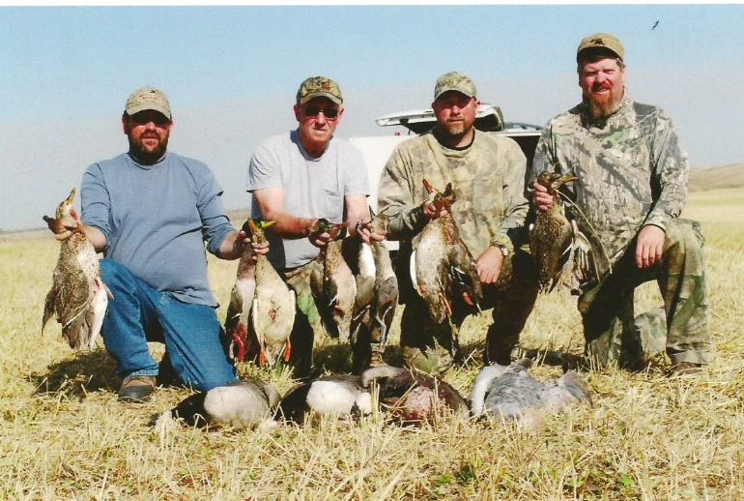
Harvey is also home to 13 religious communities offering an array of worship, child and youth group programming, vulnerable child and adult outreach, chemical dependency intervention and outreach, pastoral visitation, Boy and Girl Scout housing, and coordination of programming such as the Dakota Food Pantry via the Central Dakota Ministerial Association. These communities are noted for their vigor, sustainability, and willingness to provide core assistance when needed.

The greater Harvey area offers an enormous array of attractions for its residents and visiting public. Its annual rodeo is regionally famous, as are its park and recreation facilities, its proximity to the Lone Tree Wildlife Area, and its location within the Central Waterfowl Flyway. Its lake and river proximity are an enormous advantage to those who desire to explore the topographical features and bird and other wildlife forms found within glaciated soil areas that constitute the northern high plains upon which Harvey City was originally plated and sited. These outdoor features of the grater Harvey economic development area could be of considerable interest to GenX and GenY’ers who chose location, first on the basis of lifestyle amenities, and then on vocational and other opportunities.

Harvey’s Weaknesses
As a business community, Harvey is beset by lack of a “growth mentality” anchored on a vision of the future that includes ‘area livability’, ‘quality of life features’, and ‘employment opportunity’ for its resident population, in-migrant populations, other geographically mobile populations, and specifically catering to Gen Xer’s and millennials. Demographically, its population is aging, its school-age young people typically expect to move away from Harvey upon high school graduation, its workforce is gentrified, and some of its downtown business structures are owned by non-resident or elderly individuals who legitimately need to cash out in support of a retirement lifestyle. It presently appears that most do not structure their exit decision-making on an explicit succession plan. Along Harvey’s main north-south downtown avenue (Lincoln Avenue) 12 business sites are unoccupied out of a total of 91 such sites resulting in a 13% vacancy rate.

There is criticality across the Harvey business community relative to the features noted above. For example, presently no resident licensed lawyer is located within the community (though a succession plan that results in such capability may be underway), childcare shortages exist (construction of a new licensed facility has begun), high compensation employment opportunity ($50,000 or more per year) is lacking, and communication across the business community and within the city itself is confusing and often counterproductive. The result is that Harvey and its surrounding economic development area’s population is without critical information about foundational features such business hours, products and services available, lifestyle features and events (loosely termed making downtown Harvey “people-centric” instead of “automobile-centric”, particularly given the predilection of Gen Xer’s and millennials to eschew automobile use), availability of employment opportunity, medical care and facilities, and people-centered product advertising.

Coterminous with the above is a general malaise of support for Harvey’s downtown. This is reflective of a ‘chicken-and-egg’ conundrum wherein if downtown businesses are not open when 60% of the U.S. population’s purchasing occurs – after 6:00 p.m. daily – people won’t go downtown to acquire goods and services. On the other hand, downtown businesses cannot remain open if people don’t avail themselves of such opportunity. And, many downtown businesses do not possess enabled web sites and connectivity with customers, therefore are locked out of e-commerce opportunity. In fact, Harvey is remarkable given that its business community has made modest use of the fastest and widest Internet of Things in the world! Clearly, this must change if Harvey expects to prosper and grow its downtown.

Given its geographic location, and commerce boundaries that extend well beyond its core trade area, Harvey needs to do more to attract and keep clinical facilities within its midst. Recent “Patient Origin Studies” conducted by the Center for Rural Health located at the University of North Dakota suggest that up to 60% of the population located within Harvey’s economic development area travels out of the area in search of basic and 1st and 2nd tier specialized clinical care and durable medical products. It is recognized that people in search of tertiary medical care must leave the area given the unique nature of such care and the need for highly specialized clinicians and diagnostic/treatment laboratories. However, Harvey’s medical facilities should constitute triage centers for most patients in need of basic through 2nd tier specialized clinical care.

Harvey’s Economic Development Opportunities

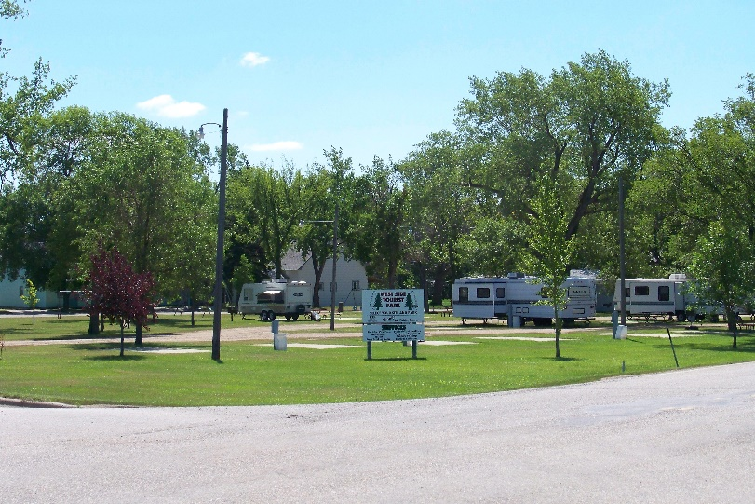
Harvey possesses a good number of opportunities to rebirth its downtown vitality and expand business opportunity elsewhere. For example, it has invested heavily in core infrastructure, possesses comparatively low indebtedness (including that of its K-12 system which ranks in the lowest state-wide tier of debt level and highest tier of student academic achievement), available real estate, senior citizen housing, unbelievable Internet of Things access and speed, and medical facilities currently exploring new models of service delivery.
Harvey City’s Westside Tourist Park

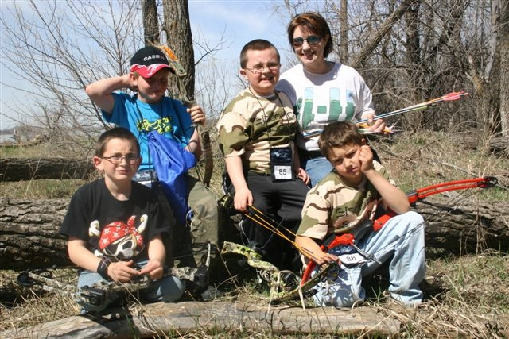
Harvey’s economic development area possesses an enormous array of recreational opportunity which could incentivize new business opportunity and product development given the ease by which people can fish, hunt, trap, target shoot, sight-in rifles, shotguns, and pistols, swim, use kayaks, canoes and boats, hike, run, bike, ride horseback, ride snowmobiles and ATV’s/UTV’s, camp, and eat out. Geographic proximity is everything and Harvey has it all, hence opportunity exists for year-around convenience/fast food outlets, full service facilities including canoe, saddle and ATV/UTV repair, fuel stops, parts availability, and unique forms of lodging. Additionally, these natural amenities could give rise to numerous additional downtown activities and events, and camps and retreats answering the clarion call emitted by other successful people-oriented downtowns for no less than 250 different event opportunities annually!

Harvey possesses an impressive array of economic development “tools”. These include its Job Development Authority (JDA) funded by a 1% city-wide sales tax, its Renaissance Zone with tax rebates along Business Highway # 52, its new Industrial Park pictured to the right, its history of prior use of USDA resources that results in city leadership familiarity with at least five different economic development programs, its Bismarck State College satellite training center for nurse education located at St. Aloisius Medical Center, its high speed Internet of Things, and the spoken commitment of its millennials in support of new and diverse economic opportunity. Opportunity exists to add training capacity in emerging technologies such as precision agriculture, automated data processing, cyber security, UAS system control, and perhaps other adventures.
Harvey’s 80 Acre Industrial Park – West Side View
When compared to cities of its size in surrounding states, Harvey possesses an enormous advantage…its access to the broadest and fastest Internet of Things in the world! North Dakota, unlike its neighboring states, invested early and heavily in the Sonnet which is a fiber optic ring around the perimeter of the state. It possesses spokes into every county seat, all K-12 educational systems, North Dakota’s institutions of higher learning, major industries including airports and truck and rail terminals, agricultural extension offices, public health departments, law enforcement centers, regional and local airports, etc. Harvey’s business community could accelerate its use of this capacity so that it captures online acquisition of goods and services at the retail level as well as marketing and advertising capability.
Harvey’s downtown area is also capable of absorbing more “developmental infill”. Space exists for new business entities, affordable housing, pedestrian “sticky spaces”, additional medical facilities and perhaps a durable medical goods entity, and more intensive media development. Web-based industry needs programmers given that the marketing and advertising world functions largely “online” almost without regard to geographic location. Downtown Harvey currently possesses radio (including notable Northern High Plains weather coverage), print, and visual media with wide economic area coverage…media which are heavily dependent on The Internet of Things.
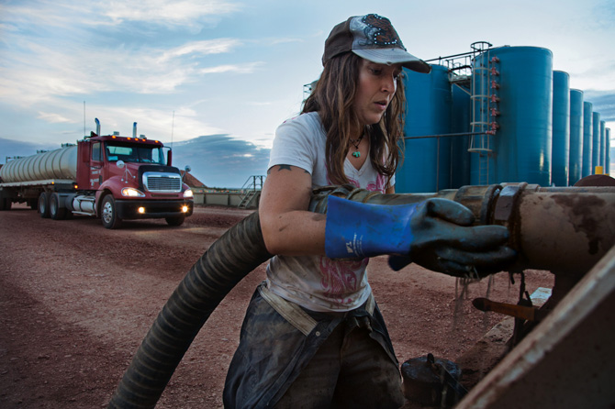
Harvey’s geographic proximity to the Bakken shale area may offer future potential for economic and residential growth. The Bakken shale is an enormous rock formation lying deep under Northwestern North Dakota and is estimated to hold approximately 18 billion barrels of oil. Bakken shale currently produces approximately 1.1 million barrels of light sweet crude oil and another 2.1 million cubic feet of natural shale gas per day. Currently, over 700 oil wells are awaiting fracking and final completion. Two features associated with these developments are now in play: (1) a new analysis of North Dakota’s shale and other oil reserves being developed by the U.S. Geological Survey which likely will feature other formations lying below or astride Bakken shale and may reach all the way east and beyond U.S. Highway 281, and (2) Harvey’s Highway # 52 location, currently east of the known edge of the Bakken. The U.S. Geological Survey is the U.S.’s largest civilian water, earth, and biological science agency, and its latest N.D.-based analysis of oil and gas reserves is expected to be publicly released in late 2018. Meanwhile, during the peak of Bakken oil exploration, Harvey’s residential population absorbed the first households wherein one member was employed full-time within the oil shale area. With resurgence of the U.S. shale industry, it should be expected that more resident households could locate in Harvey. And, there is no apparent letdown of oil development –related traffic on U.S. Highway # 52. Therefore, new economic development may emerge on Harvey’s west side as the Highway # 52 bypass affords spectacular locational and signage opportunity for transport and trucking-related industrial development as well as gas, oil, and pumping/pipeline deployment. Favorable conditions for such development emerged in late 2016, improved throughout 2017, and robust 2018 capital budgets announced by Bakken shale oil and gas producers in recent weeks validate these assumptions. It must also be noted that shale oil and gas producers are responding to investors that want to move away from operations that emphasize gross production at allowable cost and toward a more robust economic model that focuses on long-term sustainability. Such modeling could work in Harvey’s favor across time!
Harvey’s External Threats
At its final SWOT analysis session, several external threats were identified by Operation Community Partnership. Briefly summarized, they included demographic, legislative (including tax reform and other initiatives), agricultural and natural resource economic cycling, the Internet of Things, developments in financing and staffing of primary medical care, and Harvey’s past reputation for controlled drug abuse.
Harvey’s population continues to age, and its school-age K-12 system is adjusting to loss of students. Aside from area-wide reduction in female fecundity across wide swaths of rural North Dakota, in-migration of Gen-Zers, Gen-Xers, and millennials into the Harvey economic development area has slowed. This has resulted in smaller young household sizes and attendant reduction in school-age children. Coupled to this phenomenon is a looming shortage of K-12 teachers, the aging of Harvey’s K-12 building infrastructure, and voter opposition to raising property mill levels to accommodate building remodeling and potential new construction. Available skilled labor is also in short supply, as noted by the need for Harvey-area agricultural enterprises to employ temporary workers under the H2A (agricultural worker) and H2B (non-agricultural worker) visa programs, and few if any workers credentialed in computer programming, cyber-security development, web page development, or statistical analysis and data mining. Taken, these threats to future economic development are very real.
State and federal Legislative activity may challenge Harvey’s business districts. For example, the 2017 Tax Act created new opportunity for agricultural cooperatives to capitalize on producer need for more leverage with Section 199A deductions that permit 20% of crop revenue to be deducted against taxable farm income, thereby shifting year-end purchases into grain movement rather than other fixed or mobile equipment assets. Other distortions potentially affecting a rural community such as Harvey also have been codified into federal law, including Internet neutrality, dairy export restrictions under the North American Free Trade Agreement, and low usage thresholds under the renewable fuel standard (RFS) that mandates use of biofuel across the U.S. transportation system. Congressional inaction relative to DACA populations and trade distortion may also affect rural enterprises that grow commodities or extract energy and aggregate products. For example, from 2011 to 2015 net farm income contracted 93 percent in North Dakota! Such market force developments result from large swings in commodity prices for agricultural and energy products and do not serve business districts well due to huge shifts in gross income. At the state legislative level, activity that changes state aid and sales tax permitting may directly affect urban infrastructure development, job development incentivization, and accelerate aging of roads and bridges resulting from funding delays or cancellations.
The Internet of Things poses a unique challenge for downtown Harvey, and likely its Highway # 52 By-pass, its Highway # 52 Business Route, and its Highway # 3 Industrial Park. Recent national data suggest that in 2017, 70 percent of all U.S. household purchases occurred after 6:00 p.m. in every U.S. time zone, confirming as a minimum that households are making purchases in-store after 6:00 p.m. or avidly employing the Internet of Things. Short of designing and deploying its own www.harvezon.com© replicating what www.Amazon.com© can provide in a one-stop environment or relying on individual proprietors to deploy their own .com active Internet site, or extending retail business hours beyond 6:00 p.m., Harvey’s business districts shall be at the mercy of millennial, GenX and GenY shopper predilection for use of the Internet of Things. A workable response must be developed so that business districts can flourish.
Currently Harvey’s largest employer is St. Aloisius Medical Center. After review of patient origin data provided by the Center for Rural Health located at the University of North Dakota, a demographic analysis of its current medical providers, and an internal analysis of cash flow and other issues conducted by its system board, it has initiated an internal review of its medical product line, as well as its relationship with independent medical providers. The results of that review are forthcoming, and until public disclosure, Harvey will continue to contend with gaps between the cost of health care and non-metro reimbursement rates under Medicare and Medicaid programs, rising health insurance premiums for many households and employers, lack of health care benefits for many private sector employees within the Harvey economic development area, potential provision of “slim” insurance coverage for those vexed by the cost of plans presently offered in the North Dakota insurance marketplace, and the aging of the community’s medical care workforce. The latter appears to be of concern given the composition of Harvey’s primary care providers.
Finally, Harvey does possess an image problem relative to chemical dependence and drug trafficking. Mews media have provided extensive coverage of this issue, most recently across 2017 and 2018, bolstering the public image of a small rural city beset by seemingly intractable addiction and criminal trafficking problems. Among the agencies attempting to address this issue are the Harvey Police Department, Harvey Public Schools – K-12, the Wells County District Health Unit, several religious communities that provide facilities for group therapy and intervention, the North Dakota Highway Patrol, the North Dakota Bureau of Criminal Investigations, the Wells County States Attorney, and the Wells County Sheriff Department.
Transitioning Toward a Vision for the Future
Harvey Operation Community Partnership transitioned through four meetings in early 2018 wherein SWOT observations were forthcoming that enabled the above narrative to emerge. Then it began the arduous task of developing a common vision for Harvey’s future, one that envelopes “gratitude” for Harvey’s emerging lifestyles, occupational opportunity, entrepreneurial opportunity, economic opportunity, captivating “soul food”, a “blooming” downtown and its fine arts opportunities. The goal of visioning is to develop written and visualized statements of a community’s long-term goals and strategic objectives in endeavors identified by the Partnership. Visioning is typically done as an initial step of any planning process.
Ten core values have shaped Harvey’s present and appear likely to persist across the city’s future. They include:
- Compassion for others, as seen by the presence of the Central Dakota Ministerial Food Pantry, numerous funding drives for households and individuals beset by disease or sudden injury, etc.,
- Support for civic and philanthropic organizations and the debt-free K-12 educational system,
- A family-friendly environment, exemplified by the city’s extensive array of parks, public space, support groups, provision of resources for summer activity and recreation, a new city-wide childcare facility, etc.,
- Extensive support for communities of faith as evidenced by the presence of thirteen entities within the city limits, and even others outside the city but still within Harvey’s economic development area,
- Valuing of several traditions expressed ethnically within social and religious customs, dress, food products and deserts, hobbies, recreation, etc.,
- Corporate and civic hospitality,
- Proud of the city, its past and its accomplishments to date,
- Desire to be the “best” the city can be, perhaps evidence of a competitive spirit across time,
- Keen support of the Harvey K-12 educational system, as evidenced by the FFA Alumni Association, parent-teacher interactions, and wide community support for sport, and
- Valuing our youth.

Taken together, these core values suggest tremendous potential for future economic development and underpinning of Harvey’s downtown and it’s other three economic development zones. Such core values offer hope for future success and the persistence necessary for the long-haul involved with much of this nation’s economic development activity.
When visioning for the future, in 2025 for example, Harvey is typically described by five adjectives:
- Vibrant, as in a mid-tier North Dakota developing community with four core economic development zones, a bustling downtown, and its new designation by Governor Burgum as both a MainStreet ND community and an Opportunity Zone designee.
- Capable hub, as possessing a commanding economic, educational, religious, and social presence within the central region of North Dakota.
- Capital presence, as reflection of its emergence as an organic grain food milling center, a potential processing center for heritage wheat (for example Emer Wheat, an ancient form of wheat grown in Eastern Europe and the Middle East), a commanding veterinary clinic presence, a large feed milling complex, emerging information technology entities, expanding medical and other health care resources serving its population, and a debt-free K-12 educational system.
- Extraordinarily busy, as reflected in the lifestyles of its core population.
- Pulsating with economic, educational, religious, and social activity.

Buttressing the above 2025 characterizations are Harvey’s unique features. These include:
- Harvey’s relative geographic isolation (the city is located some 60-70+ miles from ‘anywhere’!
- The city is located at the nexus of U.S. Highway # 52, and N.D. Highways # 3 and 91.
- Agriculture is currently the economic engine of the city.
- Harvey possesses the largest K-12 educational system within 60 miles of any direction.
- The CP Railroad traverses the city, providing employment and freight connectivity to the region, state, our nation, and beyond.
- Harvey is located under the Central Waterfowl Flyway (featuring migrating bird and waterfowl flight) and is also located at the start of the North Country Trail System, the Sheyenne River, and close to the Lone Tree Wildlife Management Area and the Garrison Diversion Canal. For a city of its size, Harvey possesses massive public park capacity, a 9-hole golf course, ample picnic facilities, and both down-town and other people ‘sticky spaces’.
- Harvey has historically demonstrated its resilience so is prepared to survive local, regional, and national economic and political developments! In fact, Harvey has been recently designated “City of the Year” by the North Dakota League of Cities (Annual Meeting, October 2018).

As Harvey prepares to deploy strategies capable of supporting its future vision for 2025, it will be challenged by the following features:
- The reluctance of some within its boundaries to include ‘outsiders’ because it can be socially difficult!
- The penchant of some population clusters within the city who fear change and the future, thereby rendering “thinking outside of the box” impossible.
- Thus, Harvey has been noticeably slow embracing new business opportunities and also new entrepreneurs, resulting in reluctance to collaborate at key junctures in economic development.
- Should Harvey City’s population age to a significant proportion of its total population, that development could imperial future strategic economic development and carry-through transfer of business assets from one generation to another.

To address these features, and thereby harness its unique development characterizations, key adjectives, and core values, Operation Community Partnership identified eight economic development strategies proposed for the city of Harvey. These strategies do not preclude identification and development of others; rather they serve as reminders of the potential for other compelling scenarios identified by Harvey’s entrepreneurial community.
Expand local business development capability. One of the most successful long-term strategies supportive of local economic development is to grow business opportunity from within. Providing local entities access to mentorship via opportunities to connect with one another non-competitively works (“Business after Five”, “1,000 Cups”, “Friday’s @ 7:00 a.m. with Java”, etc.), as does promotion of locally planned recreational and economic events (May’s “Health, Fitness & Safety Fair”, the June Rodeo, Fourth of July Parade/festivities, downtown Harvey’s twice weekly “Farmer’s Market”, SPLASH DASH “411” and the Can DAK in mid- to late summer, etc.). Another proven strategy involves access to skill enhancement via local tech centers or learning centers that are typically housed across North dakota within K-12 educational systems, local public libraries, or innovative technology centers. Still another strategy involves “growing one’s knowledge/product pipeline” through technical
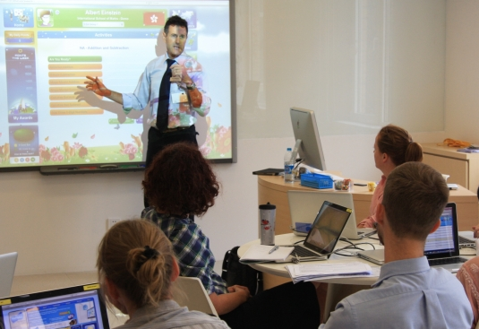
transfer from institutions of higher learning to local entrepreneurs. Each of the above is currently in the process of development within Harvey City.
Already, it is known that most new business entities prefer to locate within the U.S. Highway # 52 West By-pass corridor, rather than in one of Harvey’s other three business development areas. Thus, this development emerges as a priority focus among the myriad of activities faced by Harvey’s Job Development Authority. It also stretches Harvey’s current business development capacity as the city simultaneously scaled back its annexation activity along that corridor in January 2018. Accordingly, expansion shall have to be accomplished via close coordination between Harvey City’s Job Development Authority, the Wells County Job Development Authority under which the majority of the U.S. Highway # 52 west By-pass corridor area falls, and private-sector owners since most inquiries about available real estate upon which to place a business currently end up in the Harvey JDA office.
Meanwhile, some business entities along Lincoln Avenue downtown (and adjacent areas) and Harvey’s Renaissance Zone are currently listed for sale, others are in the process of ownership transfer, and still others are owned by entrepreneurs that have expressed keen, though non-public desire, to engage in asset transfer. Taken together, these developments could place strain upon Harvey’s small auditor and economic development staff capability. Fortunately, cooperation between Harvey’s economic development authority and the United States Department of Agriculture’s Rural Development Agency (Devils Lake), the South Central Dakota Regional Council (Jamestown), the Severson Entrepreneurship Program at Minot State University, the Red River Corridor Funds’ “Angel Fund” and the “Growth Capital Program”, and the entrepreneurial Center for Innovation located at The University of North Dakota is alive and impactful. As a one-stop entity, the JDA assists with development of business and industry loan guarantee applications, rural business development grant applications, and accessing re-lending resources. In some instances, the South Central Dakota Regional Council may also provide specific application assistance. And, small in size though it is, the JDA is willing to absorb some of the tasks associated with recruiting competent entrepreneurs, employees, and experienced entrepreneurial advisors.
Access to capital resources is imperative for Harvey’s Lincoln Avenue and Renaissance business communities. With capable JDA Board leadership and an involved City Council it can be expected that each banking institution will absorb its share of the fiscal load associated with provision of financing and ongoing operational resources. Indeed, experts experienced in redesigning vibrant downtowns identify access to capital as the first key ingredient when deploying “best practices” in entrepreneurial development! And, more is required beyond fiscal resources, including effective community-level and entrepreneurial advocacy, infectious local enthusiasm, and planful carry through by both public and private sectors.
Explore a local food hub accompanied by other retail and wholesale opportunity. “Local food hubs” are defined by the United States Department of Agriculture as “centrally located facilities with a business management structure facilitating the aggregation, storage, processing, distribution, and/or marketing of locally/regionally produced source-identified food products.” Harvey has a century-plus tradition of producing fresh food locally, largely through private gardens, and more recently a Farmers’ Market spanning at least two decades…well before national enthusiasm took off for the “food hub model.” While Harvey’s current Farmers’ Market encompasses some features of a contemporary food hub such as regular hours of operation, a volunteer governing board, modest yearly fees paid by exhibitors, and regular provision of space for exhibitors, it is largely reflective of a very local farmer’s market rather than a food hub. However, the city of Harvey could embark on a future evolutional path toward an actual food hub.
The “food hub model” has been posited as one potential solution for rebuilding crumbling downtown environments, and possesses adherents in many rural areas of the Midwest and northern high plains, including at the state level, the North Dakota Department of Agriculture. This agency has been funding local efforts aimed at creating direct farm marketing (and within larger economic development areas – local food hubs). It presently includes the city of Anamoose and the village of Tuttle, two communities arguably within Harvey’s economic development zone. Both sites are rostered within the N.D. Department of Agriculture’s “Farmers Market Brochure”, though Harvey’s own market is not similarly rostered.
The theory behind local food hubs is anchored on the observation that contemporary consumers desire forms of connectivity between food acquisition and knowledge of that food’s source. And, local or regional agricultural producers may be interested in building a farmer’s market program that connects them with potential consumers, all the while increasing consumer awareness of the benefits of fresh, locally grown food products. And, some producers maintain consistent interest in institutional sales to local or regional grocery stores, child care facilities, local K-12 public school systems, charter and other private educational institutions, post-secondary educational institutions, and other forms of commercial retail options. Within Harvey’s economic development area, there are over fifteen known vendors and other out-of-area vendors have expressed keen interest in participation in a potential food hub within Harvey City.
Given the characteristics of a food hub that features ten or more vendors, Harvey’s food hub would need to possess, as a minimum, a market manager since its market is held at the same location on a recurring basis from late spring through early-to-mid-fall (a requirement of the North Dakota Department of Agriculture). The manager ensures membership in the North Dakota Farmers Market & Growers Association (NDFMGA), collects certain information from vendors on behalf of the North Dakota State Tax Department, secures all vendor information needed to complete the Special Event Vendor Listing form, pursues liability policy coverage required by Harvey City, and develops and organizes all marketing materials and area-wide marketing outreach efforts.
Aside from enhancing its vendor cohort, including representation from a large geographically dispersed locally grown and produced food producer cohort and birthing a voluntary governing board or similar structure, siting of a future retail food hub will need to be explored as successful models housed within cities the size of Harvey include access to locally produced fresh produce, other prepared foods, flowering plants, shrubs and trees, arts, and crafts. Some food hubs also feature mobile food vendors and/or live music during business hours…both potential features of a proposed Harvey Food Hub given the area’s notoriety in the arts and music performance arenas and current interest in vending prepared food and beverages by local entrepreneurs. And, the site capable of hosting such an entity will possess different attributes from Harvey’s current ‘farmers market” site, as provision must be made for both 110- and 220-volt electrical power, overhead shelter for both exhibitors and customers, signage, lighting, and sticky space for customers that is characterized as a pleasant environment for momentary rest and provides for the special needs of young children and infants. Paved areas for both exhibitors and visitors will also be essential.
From a public health standpoint, state and local law and administrative code governs what can be legally sold at a local food hub without prior inspection or licensing. As well as on-site toileting facilities in order to suppress potential food contamination and disease transmission. As to the former, at present within North Dakota, Kuchen, Crème pies, and items requiring refrigeration are banned from food hubs. Some North Dakota health departments forbid the sale of pickles of any type that have been processed within farm sites. Sales of poultry and other meat products (excluding fish) are legal so long as these products are processed prior to sale within an establishment that is subject to federal or state inspection. Other forms of food such as wild game, canned meats or vegetables, raw milk, several forms of tea, homemade juices, bottled water from a private well/spring, expressos, lattes, and homebrew beer or wine are not allowed for sale by agricultural producers. Numerous other rules apply to agricultural producers that must be followed prior to sale within a local food hub. As to the latter, should meat and raw vegetables be offered for sale, toileting facilities are required in order to address cleansing of utensils and cutting boards, and human hand activity during and after handling such products. And, from a “customer” viewpoint such facilities contribute enormously to a comfortable sense of wellbeing.
Consider creating a Sheyenne River Park.

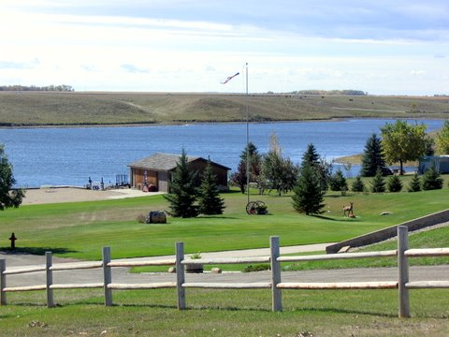
Harvey possesses notable park and recreation space, one site of which is noted to the right, perhaps spacious beyond what might be expected of a city its size. However, park and recreation areas provide activities for people of all ages through centers for organized recreational activity, stunning “greenways” for gazing and cognitive exploration of “what-if’s”, potential historical sites, swimming and boating, picnicking areas, running, and power-waking, biking, and skate boarding. Since Centennial Nature Park is now linked to G.F. Schroeder Park and Harvey City Reservoir via a paved sidewalk/bikeway, it is timely to contemplate what a refurbished Schroeder Memorial Park and an expanded park to the east on the north shore of Harvey City Reservoir (a few Harvey business owners have wondered aloud about renaming the area “Sheyenne Valley Lake”) might evolve into as a natural expansion of current facilities. Presently, these facilities include a paved entry/exit drive into the western end of G.F. Schroeder Memorial Park, a park shelter, picnic facilities, boat ramps, a swimming beach, and paved walkways within the area. The construction of additional fixed assets such as more electrical power, an adult exercise facility, more sheltering, a super slide, concrete or bituminous pads for mobile food trucks, perhaps some gaming areas, and a lake viewing kiosk that might incorporate light meal/food functionality have been suggested.
Land areas just east of G.F. Schroeder Memorial Park and south of the Bentz Addition adjacent to Harvey City Reservoir are privately owned. Substantial interest has been repeatedly voiced to the Harvey JDA for additional shared-use pathway from the southeast edge of Centennial Park-East toward the north shore of Harvey City Reservoir. This shared use path would undulate along the east edge of the reservoir finger that reaches northwest toward the edge of Advent Avenue. Nearly all of that area is under private ownership, therefore long-term leases would have to be negotiated. However, the eastern-most area located immediately south of Julie’s Addition and bordered on the east by U.S. Business Highway # 3 and 52 is under city ownership. The proposed 15th Avenue SE on the northern edge of this area has been vacated by the city of Harvey as some planning has emerged for a public campground within the area. A dual-use area comprising a modern campground with water, sewer and electrical amenities and a dedicated lakeshore recreational facility is feasible should a planned approach to development emerge. A suggested name for the park is Sheyenne River Park.
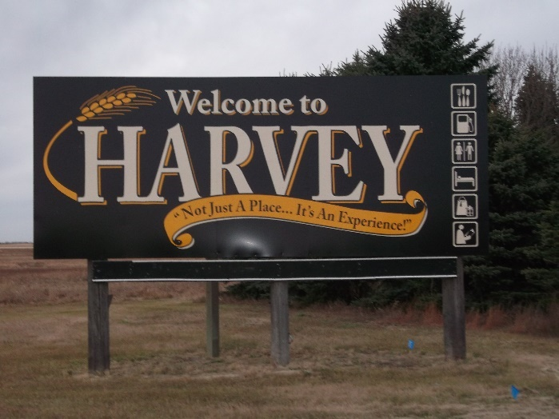
Expand downtown entity marketing. Approximately thirteen percent of main street (Lincoln Avenue) properties are currently for sale, exceeding the “tipping point” toward downtown collapse by three percent. Aside from rebirthing Harvey City’s downtown through physical adjustment, re-build, and urban renewal activity – all potentially complicated and expensive – entity marketing may offer an added adjunct to physical re-construction. Entity marketing refers to an individual company, partnership, association, club, or cooperative that has a legal and separately identifiable existence and whose processes and activities are targeted toward getting specific products or ervices to consumers. A few Lincoln Avenue business enterprises now offer online access to their product or service options but more appears necessary as today’s consumers are online more often than they are physically present within Harvey’s business entities. Already, effort has been expended by Harvey’s JDA toward redesign of Harvey’s current website so that it conforms to contemporary internet standards. This design incorporates performance specifications that specifically embody an “Amazon” like shopping feature responding to consumer desire to order and pay online for products/services that originate from business entities within the Harvey economic development area.
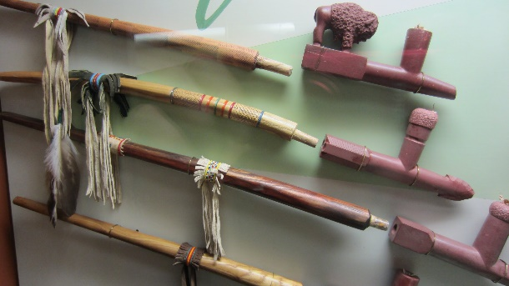
Celebrate our heritage. Harvey is a relatively young city within the annuals of the American history experience. It’s founding near the end of the 19th century certainly marks it as a young community, though among its peers on the northern high plains it is likely as old as many. So, its heritage is not so much its age, but rather its ethnic makeup and its founding roots in railroading and production agriculture that brought Chinese, German, Irish, Norwegian, Polish, Russian, and Swedish settlers to the region. However, long before these arrivals, archeological evidence exists confirming that Anishinaabe & Metis, Chippewa, and Sioux American Indian tribal members travelled along both banks of the Sheyenne River in pursuit of biota (fungi, fauna and flora), stone for fabrication of arrowheads, and quantities of bison. Ancient campsites close to Harvey have been located (some have been found as a result of oil and gas pipeline siting and excavation, and others due to agricultural land use activity) and several contain stone shards resulting from arrowhead fabrication. In the 1860’s a pony express route existed that traversed territory located approximately six miles northeast of Harvey. Additionally, Harvey’s location beneath the central North American migratory bird flight paths and its surrounding northern high plains wetlands provide the city with another theme…and enables the city to embrace its proximity to the Garrison Diversion Canal, the sustaining Garrison Conservancy District, the Lonetree Wildlife Management Area (WMA), and twenty-four other scattered Wells County-based wildlife management areas.
And, while hunting and fishing could loom large when celebrating our heritage, agriculture and rail roading need not be discounted. Other northern high plains urban areas of Harvey’s size have developed a plethora of weeknight events, weekends, theatrical and musical venues employing emergent themes from both genera. And culinary diversity abounds with faith communities sponsoring celebratory meals in addition to restaurants featuring ethnic food within ongoing menus. More could be done should the city’s civic, athletic, faith, and restaurant communities continue to create opportunity for attendance/participation at ethnic-themed events as well as for food and beverage opportunity. And, a Harvey-based local food hub could offer ethnic flavor in the food, culinary art, visual and musical arenas.
Initiate planning for a one-campus K-14 educational facility. On a national scale, numerous models have been promulgated that integrate all planned education and job training activity within a single campus. And, it is acknowledged that numerous K-12 educational systems function with geographically dispersed physical facilities, however that means information technology assets need to be deployed so that administrative, educational, remedial, and physical plant functions are integrated and coordinated. In fact, numerous vendors exist whose sole purpose is to provide such solutions to geographically dispersed educational facility systems. North Dakota is amid responding to a major economic development challenge: introducing K-12 students to STEM¹ as well as other technical skills occupations in demand across North Dakota, and developing the instructional infrastructure (fixed assets, instructors, and other resources) capable of delivering world-class workforce training at the 2-year collegiate level via development and public funding of regional “academies” that are linked to selected public school districts.
Meanwhile, within Harvey’s K-12 school district #38, exploration has been initiated about creating a one-campus K-14 facility that would be placed at the present grade 7-12 high school site. In the photo to the right Harvey’s K-6 educational facility is located upper right and its placement is recognized as within an economic zone rather than primarily residential. The photo also documents the existence of the pedestrian overpass that theoretically connects both facilities, though sidewalk/bikeway connectivity is missing. On the other hand, Harvey’s grade 7-12 facility, depicted below, is located in a residential zone approximately ¾ mile distant from the elementary facility. Across Harvey’s
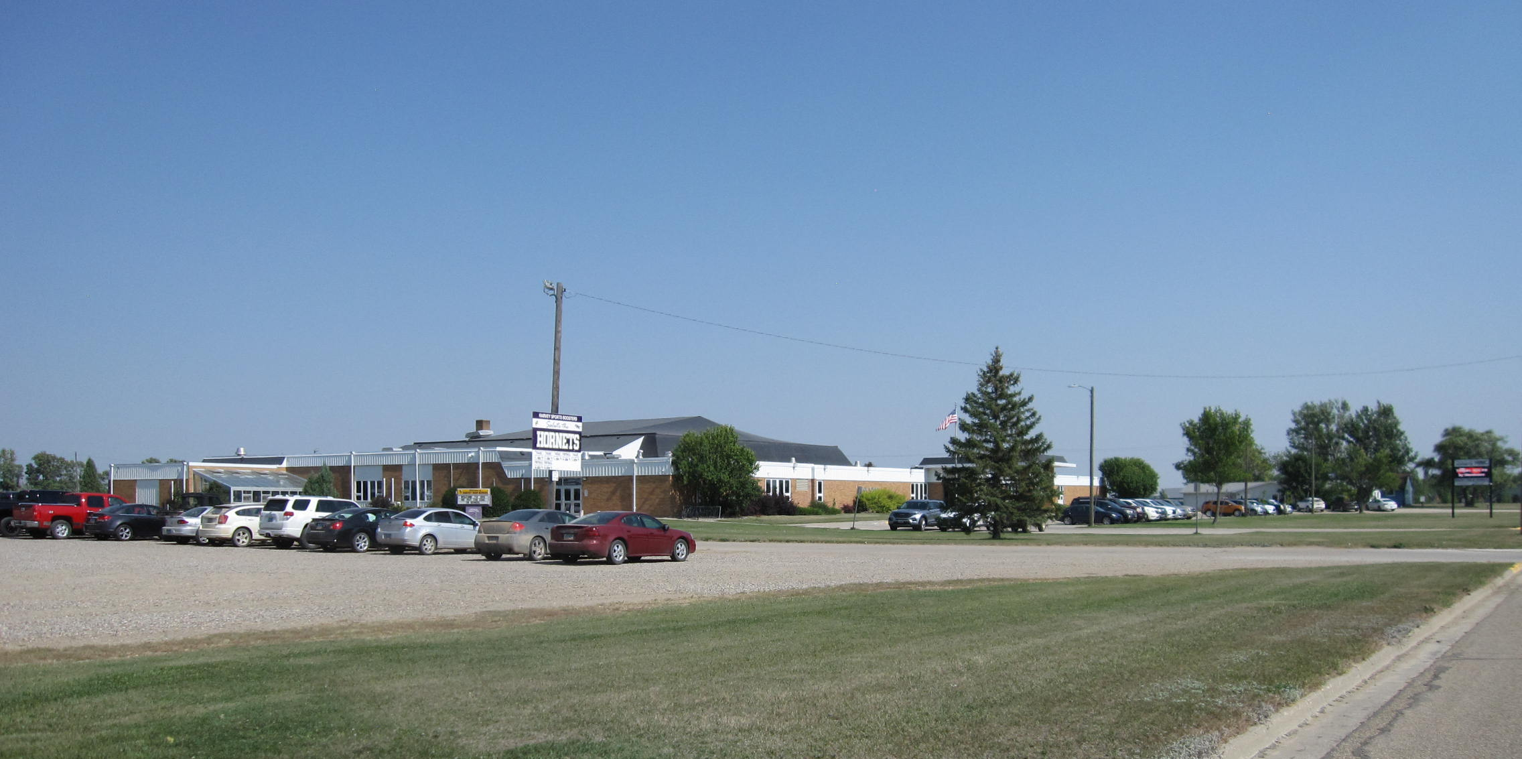 winter 2018 Community Partnership strategic planning initiative, repeated mention of one integrated K-14 educational campus emerged. This concept builds upon the idea that one campus facility rather than two would functionally address the Harvey economic development area’s education and training needs. Its functionality is premised upon certain cost savings associated with one K-14 physical facility located on the high school premises, coupled with integration of space/facilities for job training at grade 13 and 14 levels, a performance theatre seating perhaps 700 for fine arts and other performances, close-in outdoor facilities for agricultural, outdoor recreation, energy, and other vocational training, proximity to the large public sport facility located three blocks to the southeast of the campus, and vigorous internship/ cooperative education, and/or apprenticeship opportunity. These developments may provide an opportunity to create a visionary instructional setting that could (1) enhance student learning, (2) more adequately prepare students for entry into the workforce, college or university setting, and (3) provide life-long adult learning opportunity.
Harvey’s ability to sustain economic development is premised, in part, on providing access to relevant K-14 educational resources that address the cognitive, vocational attributes, information technology, and other skills necessary within a workforce equipped for full participation in the 21st century. Additionally, rural development evidence emerging across the northern high plains suggests birthing of entrepreneurial talent is an essential feature of rural communities that are beating the odds of failure. For example, Nebraska’s economically successful rural communities evidenced the following six factors in 2018:²
- A high expectation that youth will “opt in” and work hard to acquire the skills to build a better future while exhibiting a low tolerance for opting out,
- Strong, informal support systems, with neighbors helping neighbors,
- An early focus within the K-12 educational system on career pathways,
- A wealth of opportunities for youth to build life skills, regardless of the community’s size,
- Exhibiting potential challenges to accessing opportunities, but entrepreneurially developing creative solutions for overcoming them, and
- A sense of shared fate and a deep commitment to sustaining the community.

Obviously, a responsive K-14 educational system is vital to creation of local economic opportunity. It is expected that exploration of options for Harvey’s public education system will continue into the near future with a culmination of creative planning occurring sometime after 2022.
Continue design of a competitive healthcare environment. Since its creation in 1906, Harvey has possessed health care capability. It has undergone numerous gyrations across time as opportunity has ebbed and flowed relative to types and governance of health care clinic organizations, roles of public and private forms of care, economic outlooks associated with provision of such care, and the city’s capability to host clinics over time given the development of dominant demographic changes. Basic clinical care, including ability to respond to
¹STEM education is an interdisciplinary approach to learning where rigorous academic concepts are coupled with real-world lessons as students apply science, technology, engineering, and mathematics in contexts that make connections between school, community, work, and the global enterprise enabling the development of economic opportunity”.
²Northeast Nebraska Counties Defying Economic Odds.” www.highplainsjournal.com Accessed February 7,2019.

emergencies has always existed within the city and recently, substantial clinical capacity has been added to St. Aloisius Medical Center given the arrival of new clinicians, renovated clinical space, and development of new clinical product lines. Within Wells County emergency preparedness has substantially improved since 2001 and across time the county’s public health agency – Wells County District Health - has increased its staff by a factor five times its size since 1991 when it was formed and has also added significant environmental health and disease prevention and health promotion capability. It also plans to move its core administrative and clinical office from Fessenden to Harvey given the change in population dynamics within Wells County. However, the city of Fessenden would retain on-site clinical capacity. Significant challenges within the clinical care domain of Harvey City remain. Access to durable medical devices and assistive mobility technologies is only available from communities 60+ miles distant from Harvey. Fortunately, opportunity for value-added clinical capability on south Lincoln Avenue currently exists. Additionally, even though the need for on-site mental and behavioral health capability is obvious, only recently has privately owned and financed care begun to emerge. Indeed, more capacity could be developed. Presently, restorative health and provision for cardio rehabilitation is only available at St. Aloisius Medical Center and it is typically fully booked. Other avenues for physical fitness, athletic hardening, and wrestling are only feasible within high school space also used for educational purposes or at two privately-owned fitness facilities that have not been updated in decades. Adding a fully equipped adult physical fitness facility can be envisioned. Additionally, national advances in women’s care, occupational safety and health, including fitness and drug testing for over-the-road drivers, some construction and agricultural workers, and railroad employees, and environmentally-induced illness suggest opportunity for creation of additional Harvey-based clinical care. And recent emergence of health promotion and disease prevention tools routinely accessible via The Internet of Things may provide opportunity for advancing local health care via formal organization into cohorts of people sharing similar traits and interests.
St. Aloisius Medical Center
Incentivize development of additional people-concentric housing for our renters, aging and physically challenged populations. Harvey appears to be at a crossroads: without additional housing investment, its capability to even exist, much less grow and thereby recruit a competent workforce and new entrants into the community will collapse. And, housing for HAV-IT clients and other populations with physical limitations appears to be in short supply. Apparent stagnation in city-wide home improvement, except for hail and wind-damage which has been unusually timely since 2002, appears to be occurring resulting in available housing stock aging and no longer appealing to newcomers or even rural residents within Harvey’s economic development area who desire to move into the city and shed homeowner responsibilities within outlying rural areas. A small portion of Harvey’s housing stock is now fully derelict, behind on property tax debt, or essentially abandoned by non-resident owners. The city has moved rather aggressively to remove its urban blight and that effort can contribute to sustaining livable housing occupancy by limiting the spread of such blight. However, beyond limiting urban blight spread, more new housing is needed to absorb job growth and generate renewed economic viability. On the ‘plus side’ there appear to be adequate home builders and contractors, although shortages of qualified plumbing, heating and air conditioning, and electrician technicians are believed to exist. The small task force within Harvey’s Operation Community Partnership charged with exploring this arena believes that new rural-centric ideas need to be birthed. Some examples could be: (1) formation of one or more Limited Liability Corporations ’s via use of private sector resources to fund the considerable up-front cost associated with rural housing development, (2) initially focus housing development on two population cohorts, seniors in need of housing, and housing for Gen-Y and Gen-Z entrants, and (3) develop city-specific commitments from both public and private sectors that respond to multi-family housing opportunity.
A View of the Harvey Economic Development Region by Our Millennials, Gen-X and Gen-Y’ers. Across the process of engaging Harvey’s community in strategic economic planning, numerous observations from the area’s Millennials, including its Gen-X and Gen-Y cohorts were collected about Harvey City, its promise, and its “tummy-aches”. Listed below are some of the most salient perspectives from the population cohorts most likely to carry Harvey forward into the mid-2000 century and beyond:
- Harvey has a long history of being a contentious community…
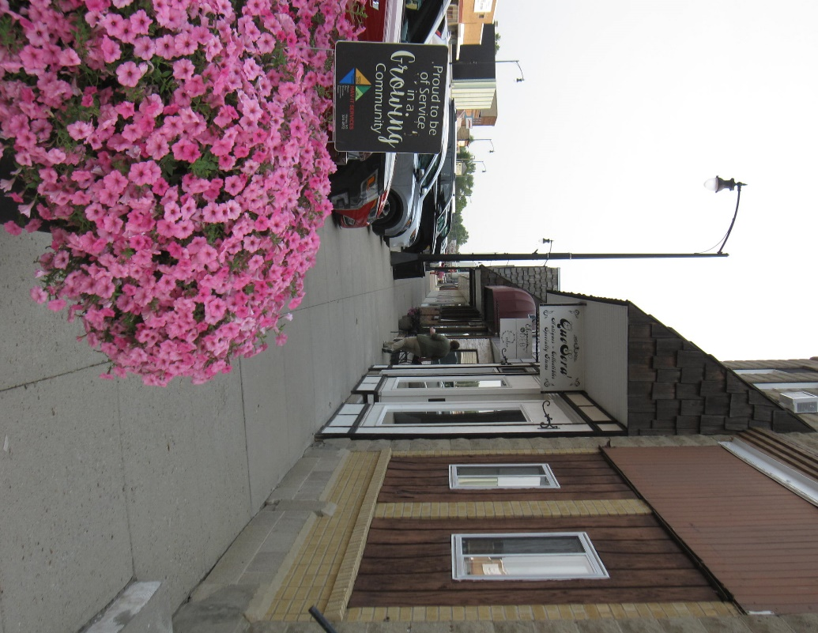
- Harvey has a lot going for it…
- Harvey has a great educational system!
- I love Harvey’s teachers…
- Harvey’s business need to grab the Internet…
- Harvey has a great downtown…
- Harvey’s downtown is accessible and pleasant.
- Harvey’s downtown is nice…
- Harvey’s business community really cares…
- Harvey needs an area fitness center possessing 24-hour access…
- Harvey needs fitness courses, preparing healthy snacks and meals, etc.
- Harvey needs a gym with opportunities for competitive leagues and athletic hardening.
Downtown in Harvey on Lincoln Avenue
- Harvey needs a new public swimming pool and “kiddie splash pad” facility.
- Harvey would be more attractive if it had a “glamping center” …
- Harvey is as great place to raise a family!
- Harvey is a community that cares – look at its food pantry, ambulance service, and fire department!
- Harvey’s K-12 educational system needs a performance theatre…
- Harvey needs a second car wash, drug store, and up-scale motel.
- Harvey’s Centennial Park is beautiful!
- Harvey’s football complex is first rate!
- Public access to Sheyenne River Reservoir is great!
- Having a downtown movie theatre is neat!
- The community of Harvey needs an indoor year-around equine event center on space now owned by the Sheyenne River Saddle Club…
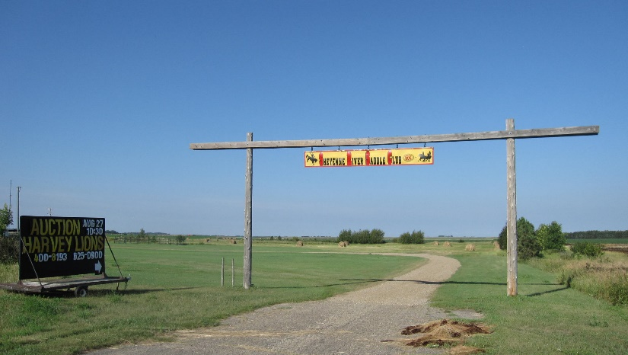
      - The public parks in Harvey really
need to develop and adhere to a
‘master plan’.
- Harvey should reactivate its fine arts
programming and performances, including
“Music in the Park” on summer Wednesday
evenings.
- Harvey needs a more comprehensive and
friendly “Farmers Market” that is in an area
Sheyenne River Saddle Club Outdoor Equine Recreation Area
without all that hot asphalt surfacing!

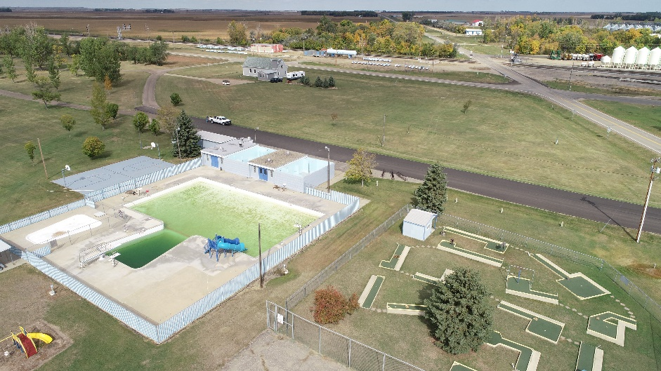
Harvey’s Gen-Z (zoomers born between 1995 and 2012) and Gen-Alpha (born from 2010 forward) population cohorts provided the following observations as the city’s Operation Community Partnership elevated voices of younger members of Harvey’s business, civic, educational, recreational, and faith entities and empowered them to share their ideas about what could make the greater Harvey area attractive to them:
- Harvey needs a bicycle repair shop…my parents can’t fix anything!
- Harvey needs an indoor horse-riding place.
- Harvey needs more good sidewalks…too many residences don’t have a sidewalk, or they are in disrepair.
- Harvey needs a good pet shelter…
- Harvey needs to allocate space adjacent to its streets and avenues for use by golf carts, ATV’s, and snowmobiles (during winter time).
- Harvey provides great sport activities year around.
Harvey’s Swimming Pool Complex
- Harvey’s parks are great places to be.
- Harvey’s religious groups are often very helpful.
- The Soo Line Railroad Christmas Train event is wonderful.

The amount of feedback associated with Harvey’s Operation Community Partnership as it processed through its strategic planning process was very remarkable. The city seized upon this structured opportunity to provide useful expertise, feedback, resources, and staff that enabled this plan to emerge. It shall be a ‘living’ document, for plans are in the works to revisit its core elements in the spring of 2022.
Appendices
List of Acronyms
- CDBG – North Dakota’s Community Development Block Grant Program (funded by HUD and USDA)
- DCN – Dakota Carrier Network (fiber optic cable provider across North Dakota)
- DOE – U.S. Department of Energy
- DOT – North Dakota Department of Transportation
- DPI – North Dakota Department of Public Instruction
- GNDC – Greater North Dakota Chamber of Commerce
- HIF – North Dakota Housing Incentive Fund (gap financing program to create affordable multi-family housing in rural and urban communities)
- HUD – U.S. Department of Housing and Urban Development
- LLC – Limited Liability Company
- MSC – North Dakota Main Street Community (has completed at least three elements of North Dakota’s process for creating vibrant communities with smart, efficient infrastructure that attract capital and talent)
- NCTA – North Country Trail Association (stretching from upper Maine to Lake Sakakawea)
- NDOC – North Dakota Department of Commerce
- NDHFA – North Dakota Housing Finance Agency
- ND.gov – official portal for North Dakota state government
- NDSBC – North Dakota Small Business Development Centers (offices located in Belcourt, Bismarck, Dickinson, Fargo, Fort Yates, Grand Forks, Jamestown, Minot, and Williston)
- NDTO – North Dakota Trade Office
- NDUS – North Dakota University System
- RDFC – Rural Development Finance Corporation (the rural development financing arm of North Dakota’s electric and telecommunications cooperatives)
- RZ – Renaissance Zone (physical urban zones created, managed, and approved by local zone authorities with the concurrence of the N.D. Division of Community Services within the N.D. Dept. of Commerce and the Office of State Tax Commissioner)
- RWIP – North Dakota Regional Workforce Impact Program (providing grants to regional workforce entities for development of innovative and sustainable workforce solutions)
- SCDRC – South Central Dakota Regional Council (regional economic planning agency located in Jamestown)
- SND – Snowmobile North Dakota (statewide organization dedicated to trails maintenance, safe snowmobile operation, and fostering local enthusiasm for the sport)
- TechND – Technology Council of North Dakota (embracing North Dakota’s technology enterprises, including the computer science and information technology sectors)
- USDA – United States Department of Agriculture

Website Addresses
- https://www.commerce.nd.gov/straegy-transformation/state-data-center (for population data)
- https://taxinfor@state.nd.us (for economic development tax information)
- https://ndsbdc.org (North Dakota Small Business Development Centers)
- https://www.ednd.org (Economic Development Association of North Dakota)
- https://ndchamber@ndchamber.com (Greater North Dakota Chamber of Commerce)
- https://gdfcd@bdcd.org (Garrison Diversion Conservancy District)
- https://tredlin@scdrc.org (South Central Dakota Regional Council)
- https://rd.usda.gov/nd (United States Department of Agriculture – Rural Development – RBDG Program)
- https://commerce.gov/bureaus-and-offices/eda (United States Department of Commerce – Economic Development Administration)

Economic Development Area Demographics
Population data are essential to economic planning. However, most data currently available are derived off the 2010 Decennial Census. Most data pertaining to the 2020 Decennial Census will not be available at useful local levels within the state of North Dakota until late fall, 2022, if then. Below are current estimates and a few useful data indicators from 2020 that have been officially released to date by the U.S. Census Bureau.
- Total estimated population of the Harvey Economic Development Area in 2010 = 17,102 people
- Total population of the city of Harvey in 2020 according to the Decennial Census = 1,650 people
- Total population of the city of Harvey in 2021 based on U.S. Census Bureau estimates = 1,606 people
- Total population of the city of Harvey in 2022 based on U.S. Census Bureau estimates = 1,624 people

- Total population of Wells County in 2020 according to the Decennial Census = 3,982
- Total number of housing units in Wells County in 2020 was 2,338
- Total number of employer establishments in 2020 was 172
- Median household income in 2020 was $56,519
- Total number of households in 2020 was 1,941
- The employment rate in Wells County in 2020 was 59.7%
- Total proportion in Wells County without health care coverage in 2020 was 2.9%
- Proportion of the Wells County population with a Bachelor’s Degree or higher was 22.2%

